Reading books in Libby  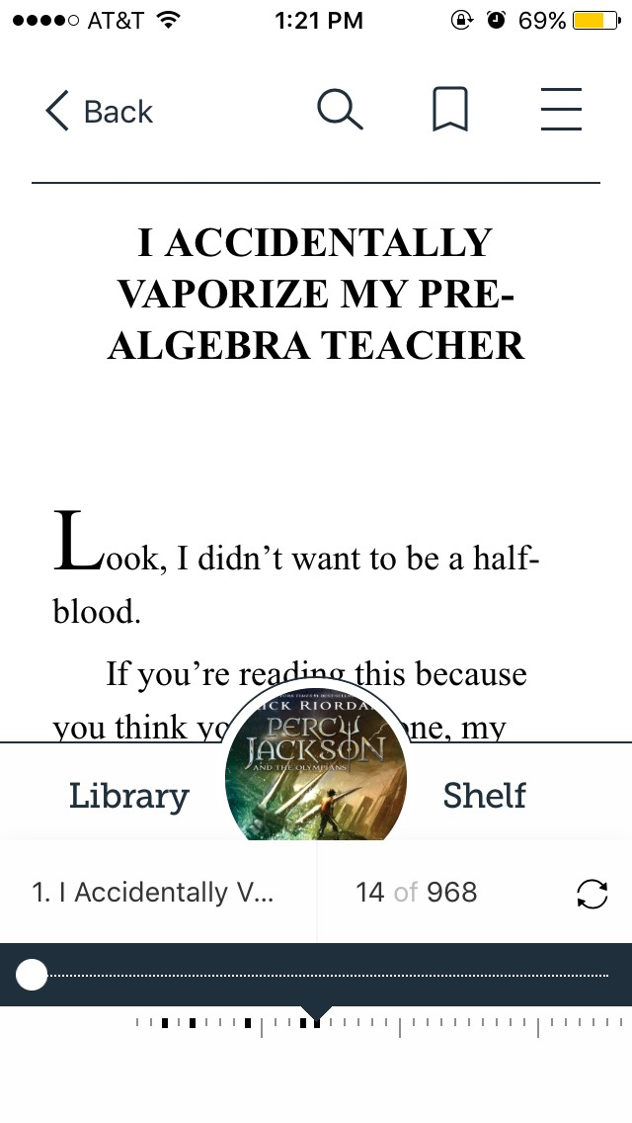  To read a book in Libby, merely click on the “resume” or “open books” options by the item while in your shelf. This will open the book or audiobook.  - You can enlarge pictures by clicking on them.  - You can access the menu options (allowing you to move within the book, bookmark a page, or return to the shelf or library browsing, etc) by swiping up.  You can access more options about an item by clicking on the image of it.  - You can renew a loan, return a title early (they normally return automatically), or even tag an item. Tagging an item allows you to say you liked something, disliked something, or more. You can create your own tags as well.  Items will be returned automatically.  Only items that can be downloaded are available on Libby – items that must be read online are not. | Peru Public Library  We’re more than just books!  We’re a community resource and a place to gather.  We do offer books, but we also have movies, audiobooks, genealogy books, internet access, meeting rooms, a digital library that has e-books, e-audiobooks, e-magazines, movies, and more!  Contact Us  Phone: 765-473-3069  Email: perupubliclibrary@yahoo.com  Web: www.peru.lib.in.us  Peru Public Library  102 East Main Street,  Peru, IN 46970 | Peru Public Library  - Using Libby and the digital library  - More than just books!
How to use Libby and our digital library  Getting Libby (an App) Set up  You will need to download Libby onto your device. There are system requirements: you will need Windows 10 or Windows 10 mobile; iOS 9.0 or later if you have an iPhone, iPad, or iPod touch; or 4.4 or newer for Android devices.  After you have downloaded the app, open it and select the digital library you want to use (Peru Public Library).  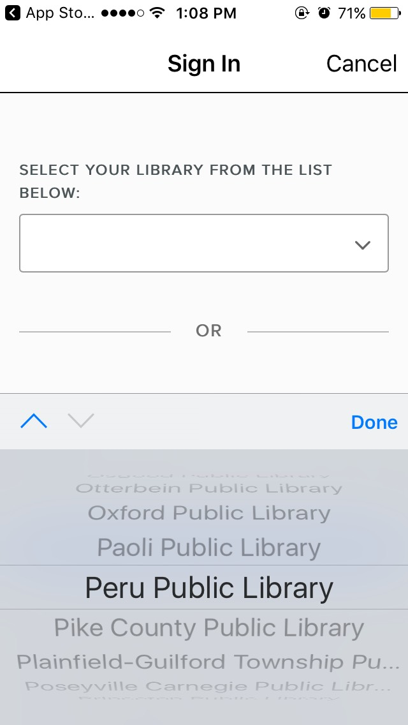  Sign in by selecting the library again from a drop down menu before entering your library card barcode number and your online account password.  You are now signed in and shouldn’t have to sign in again. You can add additional library cards to the account, if you want. You can switch between libraries and cards if you have multiple ones linked on Libby. | Finding something to read  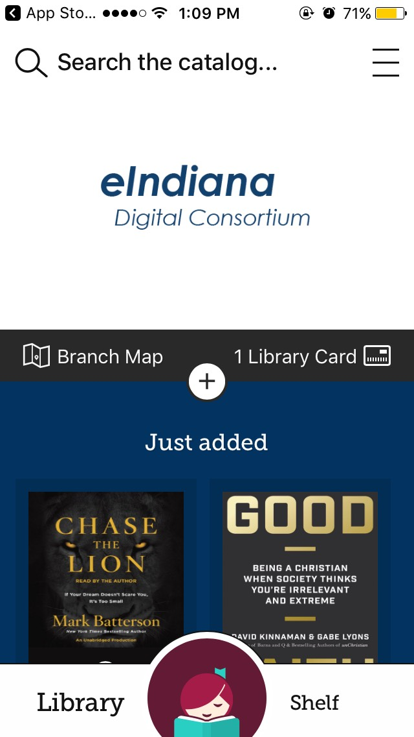  You’ll see a scrolling (you can scroll down to see more stuff) page which you can browse. You’ll see various books advertised as well as a list of different subjects you can chose to look through, listed as collections. This is the main page. You can also search the catalog at the top of this page.  Learn about Libby and download the app here: https://meet.libbyapp.com/?utm_medium=lightning_banner&utm_source=lightning&utm_campaign=libby  Borrowing an item  When you find an item you like, you can either select the item and look at a informational page on it from which you can borrow it if desired, or you can immediately borrow it (or place it on hold, if it is already checked out by someone else) using the “borrow” option given directly beneath the item. | Once you have selected “borrow” on something, a page will come up showing the card you are using, the item, and how long you are borrowing the item for. There will be a large borrow button at the button. Click on this to finish borrowing the item.  You can now either open the book or go to the library shelf and see everything you have checked out. You can also return to browsing.  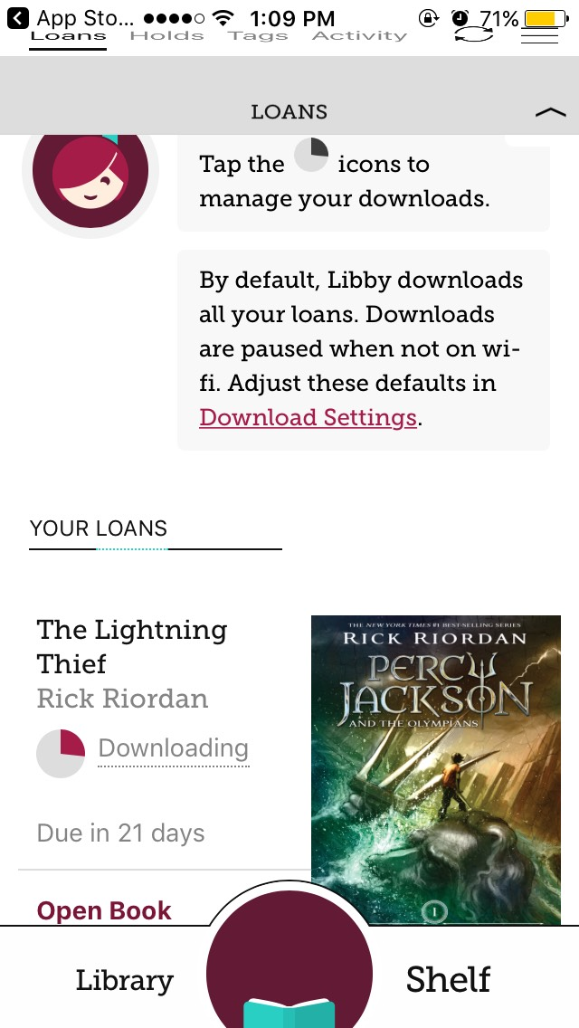  The Shelf  You can see your loans here on the library shelf. Items you borrow will start to automatically download here unless you change that in settings, the bars symbol in the upper right hand corner.  You can go to your loans, holds, tags, or activity by selecting the desired section at the top of the page.  Clicking on “Library” on the Library shelf bar along the bottom will you to the browsing or search page you had before.

