Using our Digital Library
Our digital library is called eIndiana Digital Consortium but it is accessed through Overdrive.
To check out items:
- Access Overdrive and eIndiana Digital Consortium by either opening up the Overdrive app or Libby, or by going to the Overdrive website located at https://cidc.overdrive.com/.
- Log–in to your account. You will need your library barcode number and your pin number (password).
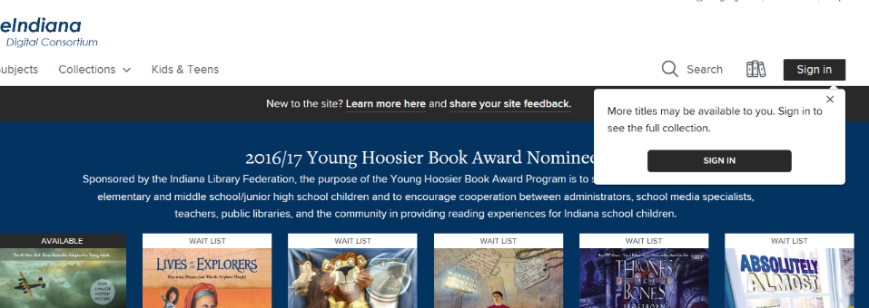
  - If using the website, sign in as directed at the link to the right of the main Overdrive page, shown here.
  - If using Libby, you shouldn’t have to resign in once you’ve linked your library card, but you can switch which card or library you are currently using by clicking on the menu symbol and selecting those options from the drop-down menu.
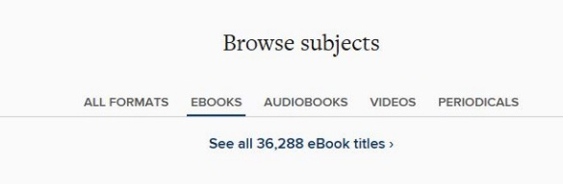
- You can either browse the items shown on the main page, browse by subject, or do a search, using the search bar provided at the top of the page.
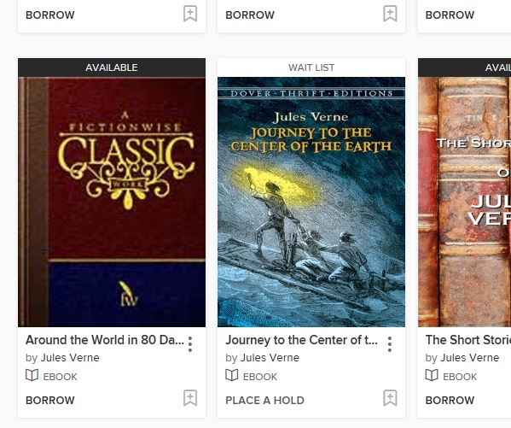
- Items will be listed as Available or Wait List. If available, you can go ahead and check them out immediately, if they are wait listed, someone else is reading them but you can place them on hold. You will be automatically emailed when a hold becomes available.
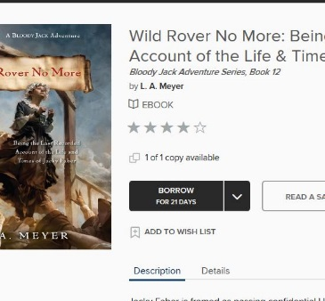
- You can either select an item, which will take you to a page with more information about it, or you can select to borrow or place a hold on an item immediately, selecting the appropriate option at the bottom of the item’s listing.
  - If you select an item, you will be able to read a description, read a sample, or borrow the item from that item’s information page.
- After you have borrowed an item, you can either go to your loans (that option will be where the borrow option was listed) or continue looking at items. Your loans page is where everything you have checked out is saved.
- Once you go to your loans page, you will see every item you have checked-out listed there.
  - You can then select how you want to read or listen to an item.
  - If using the Overdrive website:
    - Some items can be read online, which means you merely open them up in a new tab on your browser.
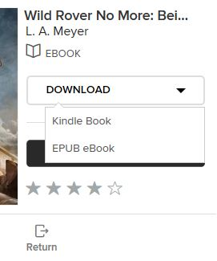
    - Some items must be downloaded, often to your Kindle device or to the Kindle app (available for desktops, mobile devices, and tablets).
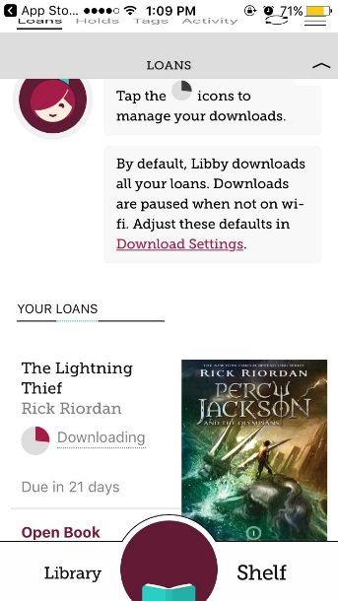
    - Select the option you want. If downloading an item to Kindle, you will be taken to Amazon where you must then sign into your Amazon account and select the “Get library book” button on the right, and then select what device you want the item automatically sent to. The item will start downloading on that device the next time you open up the Kindle app on it.
  - If you are on Libby:
    - The items will start downloading automatically (that setting can be adjusted), and you can then read the book on Libby even if offline later.
    - You can also select to send some items to Kindle, if desired. The process will be much the same as above in that case.
  - If you use both Libby and the Overdrive website, be aware that books will not sync between the two. Libby downloads the books and so will only sync materials on Libby if you have it on multiple devises.
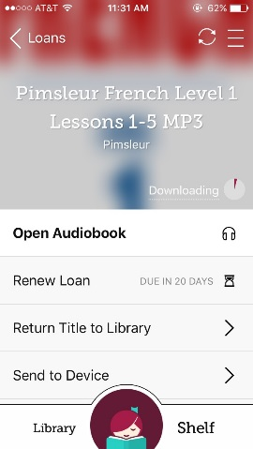
- Items can be checked out for 7, 14, or 21 days and are returned automatically – you never have to worry about late fees!
  - Items that were not downloaded to Kindle may be returned early via your digital library loans page on Overdrive or the library shelf in Libby.
  - Items downloaded to Kindle may be returned early through the “Manage Devices” page on Amazon.
  - Items on Libby may be returned early by selecting the title on your shelf, and clicking on “Return Title to Library”.

